Reflective Research Essay
Topic – Accessibility within gaming for new gamers.

Introduction.

Are games accessible to people who do not play games? The Oxford English Dictionary (2011) defines Accessible as,
“Able to be (readily) understood or appreciated.”
This essay will be looking into how easy it is for people who do not normally play games to get into a game. It will be looking into how games start and how tutorials introduce players to the mechanics and controls of that game. It will explore how players learn and why some games do a better job of teaching gameplay than others do. It will also be looking at the difference between a new gamer and an experienced gamer, and how games tend to make assumptions when delivering their tutorials, for example assuming players know the movement keys are W,A,S, and D. To examine this in depth two non-gamers (my parents) have agreed to play a selection of games and to record their experiences as a case study for this essay.
Gamustra (2019) reviews effective teaching/learning methods applied to game tutorials. In this essay the ways in which people learn are discussed with reference to example games.
In addition to the ways in which game are learnt Gamustra (2010) also notes,
“No one likes tutorials. Marketing doesn't like them because they are never done until the very end of the project. Producers don't like them because they can't spare the resources to make one. The team doesn't like them because they've been living, eating, breathing and sleeping this product for so long they can't imagine anyone NOT being able to figure it out. Finally -- the users rarely like them because they simply don't teach anything well in any way. Yet tutorials are the players' first contact with our product -- their first impression of our work. We only get one chance and we usually blow it.” pp1

This essay focusses on the issue of poor teaching methods above.
Tomb Raider [Crystal Dynamics 2013] is the main focus of this essay because I have not played it so I can use my first experience of it as a counter point and compare how an experienced gamer sees the start of the game compared with my two test subjects.

How do we learn?

As people learn in different ways it is important to consider this when designing a tutorial. According to Othman and Amiruddin (2010) and Fleming (2006) who use the VARK (Visual, Aural, Reading, and Kinesthetic) learning style model there are four main ways we learn.
The VARK model is a development of the VAK model (Visual, Aural, and Kinesthetic) Barbe (1979). We can break down the VARK model into the following learning styles:
- Visual Learners: Find it easier to learn using visual aids like graphs, pictures, and flowcharts to name a few.
- Aural Learners: Find it easier to learn using sound so tend to learn better by asking questions and be being told how to do things.
- Reading Learners: Find it easier to learn by reading books, or research papers.
- Kinesthetic Learners: Find it easier to learn by doing and getting involved in the task to allow it to sink into their memory.
Data from VARK learn (https://vark-learn.com/research-statistics/) shows that most people who only identify with one style of learning tend to consider themselves Kinesthetic learners. However over 66% of the population identify themselves with more than one type of learning. Even in this case Kinesthetic is still the most prevalent, with Aural coming in a distant second.
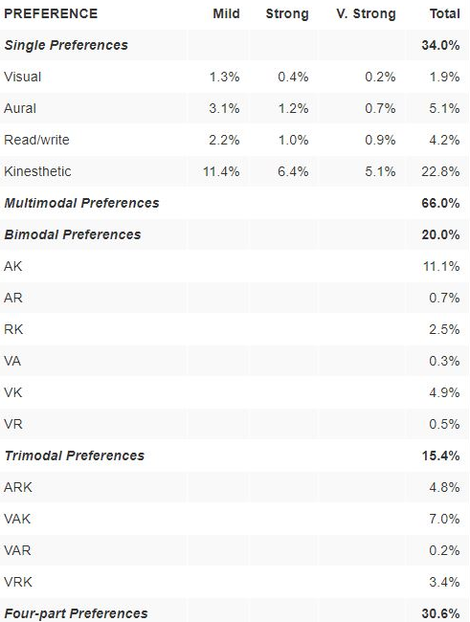
Figure 1: Distribution of Learning Preferences (online image) (Source: https://vark-learn.com/research-statistics/)

The Games

Many games tend to do a bad job covering more than one of the above styles. However, games by their very nature use the Kinesthetic learning style as you must do things within a game to get anywhere at all. This means that as one person will find it easy to get to grips with a game another person may struggle. As will be shown when it comes to this case study this is clearly the case.
The other issue games face is that they are predominantly designed for entertainment. Because of this many gamers find tutorials boring (myself included). The GDC talk by Fan (2012) says a tutorial needs to do a few things including,
- A tutorial should not feel like a tutorial,
- It should get the player to do rather than read,
- Give them time to use what they have learnt before adding a new thing,
- Do not continually get the player to the repeat the same action,
- Use as few on screen words as possible,
- Use visuals to teach,
- The more invested the player is the more willing to learn they will be.
Even through the main case study will be based on Tomb Raider a few other games are included to really get an understanding of the issues new gamers face when playing games for the first time.
However, Razbuten (2019) shows games make assumptions that the person playing them at least knows the basic mechanics. Some of these issues identified, for example camera control using mouse, were also repeated in this study.
Below is a brief break down of the games picked for use in the case study, why they were picked and the type of learning style they use.
Game | Reason | Learning Styles
Age of Empires 2: Definitive Edition [ Xbox Game Studios 2019] | Picked as it had a very linear tutorial campaign. | Aural, Read, and Kinesthetic
Command and Conquer Remastered Collection [Electronic Arts 2020] | Picked as a counter point to Age of Empires 2 as it has no tutorial | Kinesthetic.
Final Fantasy 9 [SquareEnix 2000] | Picked because it is a Role-playing game, and uses text boxes to teach you things | Read and Kinesthetic
Portal 1 [Valve 2007] | Picked as it is considered to be very good at introducing people to the mechanics of the game | Read and Kinesthetic. Later Aural is introduced
Portal 2 [Valve 2011] | Picked to see if Valve and learned from Portal 1 and added any new information to the tutorial. | Aural, Read, and Kinesthetic
Tomb Raider [Crystal Dynamics 2013] | Picked as the author has not played it. Barely has a tutorial, | Visual, Read (just), and Kinesthetic

Case studies.

The authors parents were picked to be the testers because their total gaming experience can be summed up as the occasional game of sudoku online. They were given no context to what the games were and were provided with no information at all until they had played all the games.
During the test they were alone so could provide no information of the games to each other. Before they both started, I asked them what sort of learner they considered themselves to be. Tester 1 (My Mum) considered herself to be Aural only. Tester 2 (My Dad) considered himself to be Read and Kinesthetic.
As for myself I consider myself as having an Aural and Kinesthetic learning style.

Learning from the past.

One of the things this essay wanted to briefly examine was to see was if a Games company would learn from their mistakes to this end, Portal 1 and Portal 2 were picked. Both testers struggled with Portal 1 as they did not realise, they could move the mouse to change the camera angle, this was because the tutorial did not tell them to. However, in Portal 2 the first thing you are told to do is look up and down. Granted you are not told how but it was an improvement, and both testers realised quite quickly how to.

Good versus Bad tutorials in the same genre.

Another area that was examined was how two games of the same genre in this case real time strategy varied wildly in their approach to a tutorial for this Age of Empires 2: Definitive Edition and Command and Conquer Remastered Collection were picked. Both testers picked up Age of Empires 2 easily as the tutorial from there point of view was very good. (if a little long for Tester 1) However Command and Conquer gives you no tutorial at all so both testers had no clue as to what they were doing. The only reason that Tester 2 managed to play it was because they had played Age of Empires 2 first so tried the same controls as they had used for that game. This highlights the point made in the introduction that most games make assumptions that you have some basic knowledge of video games.

A focus on Reading.

As Fan (2012) had stated that a tutorial should.
“get the player to do rather than read”
Final fantasy 9 was uses to test this as this game uses large text boxes to teach you what to do. Tester 1 struggled with this game, they could not take in the information in the way it was shown and as a result of this spent at least 15 minutes trying to work out how to light the candle in the first room, when it came to the first fight they as had no idea what to do so ended up dying. Tester 2 on the other hand found this a lot easier to pick up as they found this way of being shown things worked for them. However, over all this is a bad way to do things as almost everyone would just skip them and even if they did not there is far too much information being explained all at once.
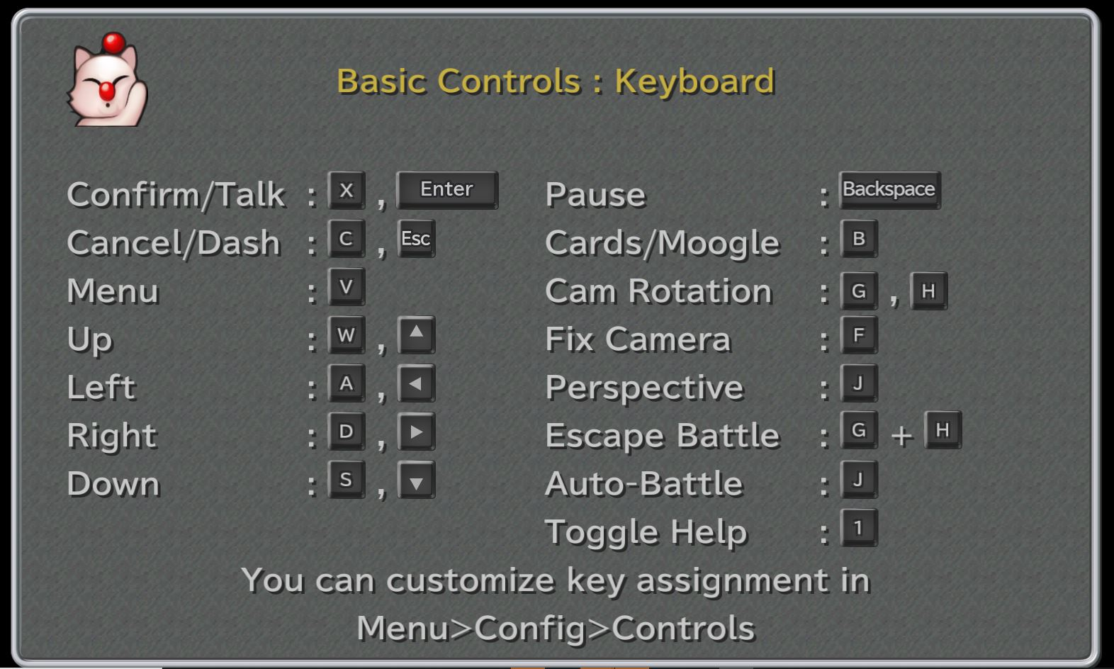
Figure 2: Text page 2, from Final Fantasy 9 (In Game screen shot)

Case study of Tomb Rader

Having never played the new Tomb raider games I considered this would make the perfect case study of how a gamer and a non-gamer approach a new game. The game has no tutorial, and It is very easy to miss the few prompts it gives you. It does not use and voice commands When playing it the first time I found it frustrating in the way it starts with you the moving the A and D keys in time with the rope swing, if you did not know any better like my testers did not you would remain hanging in mid-air for ever. Even if they had guessed the right keys there was nothing to tell them they were doing it right meaning that if you missed a swing you would assume that you were using the wrong keys, this was the case with both testers.
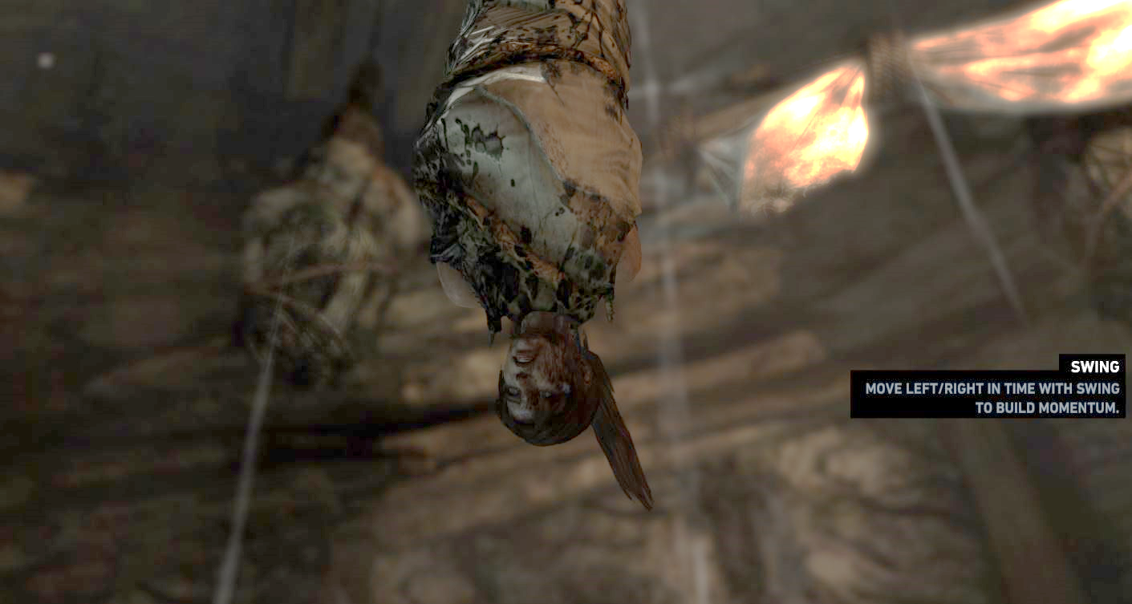
Figure 3: Start of game showing swing instructions, from Tomb Rader (In Game screen shot)
Once I had freed Lara from the rope, I quickly realised that the game was using colour (Red for where to go, White for flammable objects) to let you know where to go. However even this was not clear, and I only realised because I was play testing it for this essay so therefore examining the game more closely than I normally would. Under normal circumstances I would have not given it a second thought. Neither of the testers realised this. Both missed prompts and because of that they got turned around very easily as they assumed, they had gone the wrong way.
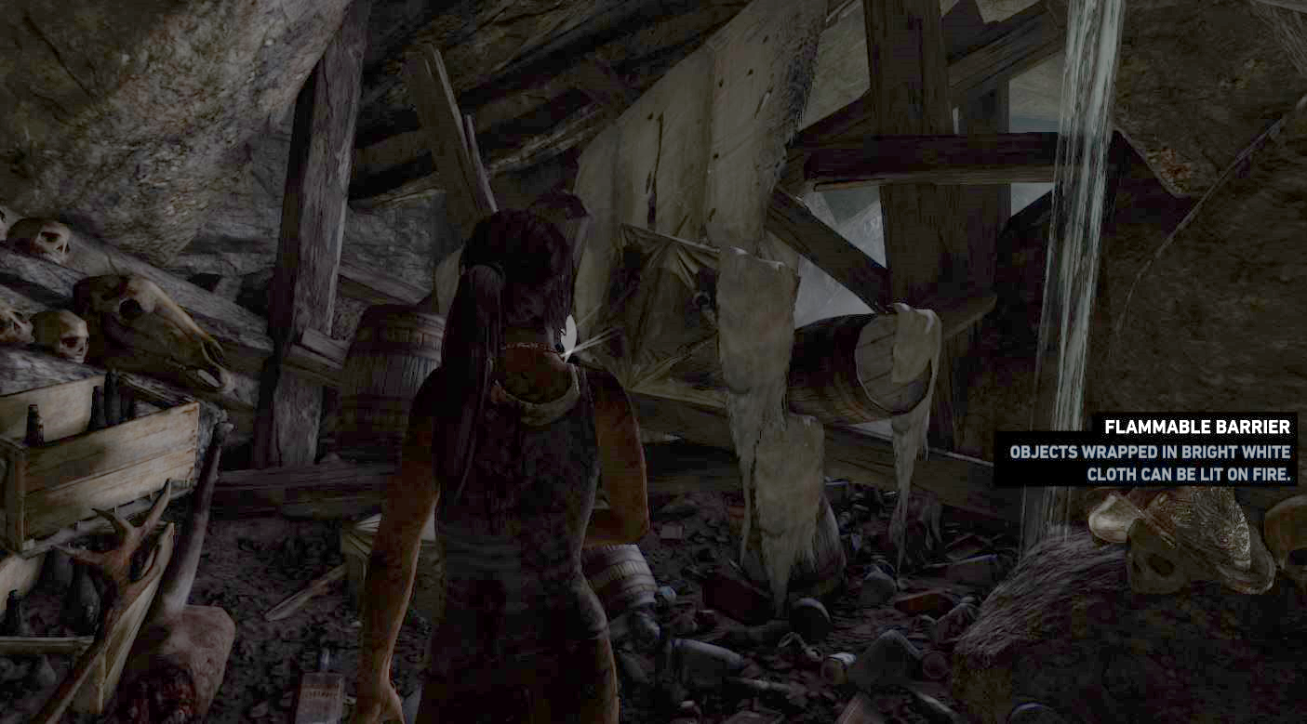
Figure 4: First flammable sheet blocking the path unless you have the torch, from Tomb Rader (In Game screen shot)
Both got very frustrated very fast with this game and would have stopped playing a lot earlier if it were not for the test. Tester 2 summed it up like.
“Without any detailed knowledge of how to play a game you will stand no chance of being able to play this game.”

Conclusion.

One thing became abundantly clear as during the tests of the various games, was that the testers had totally different approaches to how they did things.
Tester 1 for example did not move at all in portal 2 because they had not been told to by Wheatley. Wheatley had told them to say apple (hit space) but as Wheatley did not tell them to move from the door they did not. This was reflected through-out the other games they played.
Tester 2 on the other hand wanted to explore and found it a lot easier to follow on screen prompts however they did not seem to play any attention to any NPCs etc… talking to them meaning they missed a lot of things in some of the games they tested. The clear example of this would be In Portal 2 he missed what Wheatley was saying so had no clue what he was meant to be doing in regards getting the portal gun.
This trend reflected in all the other games tested where Tester 1 would miss a lot of the onscreen prompts as they were listening to things, and Tester 2 would miss any commands given.
There is evidence that game designers do learn and improve through this can be seen through portal 2 where they added voice instructions right from the start and made the player use the mouse to look up and down as the first command.
In my view a good way to get a tutorial right would be how Age of Empires 2: Definitive Edition does it. It totally holds you hand and shows you the basics from what mouse button to click to how to scroll the screen and so on. Even through it clearly is a Tutorial it does not feal like one. It is also presented as just another campaign with in the game, meaning it can be played on 3 different difficulty levels, its broken down into 6 or 7 individual missions, and if you like you can totally ignore it and just play the other campaigns as everything is available from the main menu. Both the testers found this to be one of the easiest games to pick up and get to grips with because it covered everything from the basic to the more advanced aspects of the game, and it did in such a way that it covered three of the four learning styles that are included in VARK.
Games need to spend time considering this and making it possible to have the tutorial presented in different ways to suite peoples learning style.

References.

Barbe, W. B., Swassing, R. H., Milone, M. N., (1979). Teaching through modality strengths: concepts and practices. Columbus, Ohio: Zaner-Bloser
Crystal Dynamics (2013). Tomb Raider. Microsoft Windows.
Electronic Arts (2020). Command and Conquer Remastered Collection. Microsoft Windows.
Fleming, N., (2006) Learning Styles Again: VARKing up the right tree! [Online] https://www.vark-learn.com/wp-content/uploads/2014/08/Educational-Developments.pdf [Accessed 11 November 2020].
Gamasutra (Ray, S. G.) (2010) Tutorials: Learning to play. [Online] https://www.gamasutra.com/view/feature/134531/tutorials_learning_to_play.php [Accessed 21 November 2020].
Gamasutra (Hedges, N.) (2017) Video Game Tutorials: How do they Teach? [Online] https://www.gamasutra.com/blogs/NathanHedges/20171013/307378/Video_Game_Tutorials_How_Do_They_Teach.php [Accessed 21 November 2020].
GDC Vault (Fan, G.) (2012) How I got my Mom to Play Through Plants vs. Zombies. [0nline] https://www-gdcvault-com.ezproxy.falmouth.ac.uk/play/1015541/How-I-Got-My-Mom [Accessed 15 November].
Marveldel Carmen Valencia Gutierrez.2018, The Styles visual, Auditory, Kinesthetic and Competences in the Classroom.
Int J Recent Sci Res. 9(6), pp. 27679-27682. DOI: http://dx.doi.org/10.24327/ijrsr.2018.0906.2310
Marveldel Carmen Valencia Gutierrez.2018, The Styles visual, Auditory, Kinesthetic and Competences in the Classroom.
Int J Recent Sci Res. 9(6), pp. 27679-27682. DOI: http://dx.doi.org/10.24327/ijrsr.2018.0906.2310
Marveldel Carmen Valencia Gutierrez.2018, The Styles visual, Auditory, Kinesthetic and Competences in the Classroom.
Int J Recent Sci Res. 9(6), pp. 27679-27682. DOI: http://dx.doi.org/10.24327/ijrsr.2018.0906.2310
Marveldel Carmen Valencia Gutierrez.2018, The Styles visual, Auditory, Kinesthetic and Competences in the Classroom.
Int J Recent Sci Res. 9(6), pp. 27679-27682. DOI: http://dx.doi.org/10.24327/ijrsr.2018.0906.2310
Othman, N., Amiruddin, M. H., (2010) Different Perspectives of Learning Styles from VARK Model, Proc. Social and Behavioural Sciences, 7(C), 652-660, [Online] https://www.sciencedirect.com/science/article/pii/S1877042810020926 [Accessed 7 November 2020].
Oxford English Dictionary (Unknown) Accessible, adj. [Online] https://www-oed-com.ezproxy.falmouth.ac.uk/view/Entry/1034#eid40171410 [Accessed 21 November 2020].
Razbuten. (2019) What Games Are Like for Someone Who Doesn’t Play Games. [YouTube user-generated content]. Available at: https://youtu.be/ax7f3JZJHSw [Accessed 15 November 2020].
SquareEnix (2000). Final Fantasy 9. Microsoft Windows.
Valve (2007). Portal. Microsoft Windows.
Valve (2011). Portal 2. Microsoft Windows.
Xbox Game Studios (2019). Age of Empires 2: Definitive Edition. Microsoft Windows.

Barbe, Walter Burke, Swassing, Raymond H., Milone,
Michael N. (1979). Teaching through modality strengths:
concepts and practices. Columbus, Ohio: Zaner-Bloser
Barbe, Walter Burke, Swassing, Raymond H., Milone,
Michael N. (1979). Teaching through modality strengths:
concepts and practices. Columbus, Ohio: Zaner-Bloser
Barbe, Walter Burke, Swassing, Raymond H., Milone,
Michael N. (1979). Teaching through modality strengths:
concepts and practices. Columbus, Ohio: Zaner-Bloser

Note that this is Kinesthetic.
Note the preference to the Kinesthetic over the reading method of learning
A clear example of the Visual approach to learning.

